Ideation Phase
Define the Problem Statements

Date | 31 March 2026
Team ID | SWTID-2026-5494
Project Name | Automating Employee Data
Maximum Marks | 2 Marks

Customer Problem Statement Template:
Create a problem statement to understand your customer's point of view. The Customer Problem Statement template helps you focus on what matters to create experiences people will love.
A well-articulated customer problem statement allows you and your team to find the ideal solution for the challenges your customers face. Throughout the process, you’ll also be able to empathize with your customers, which helps you better understand how they perceive your product or service.
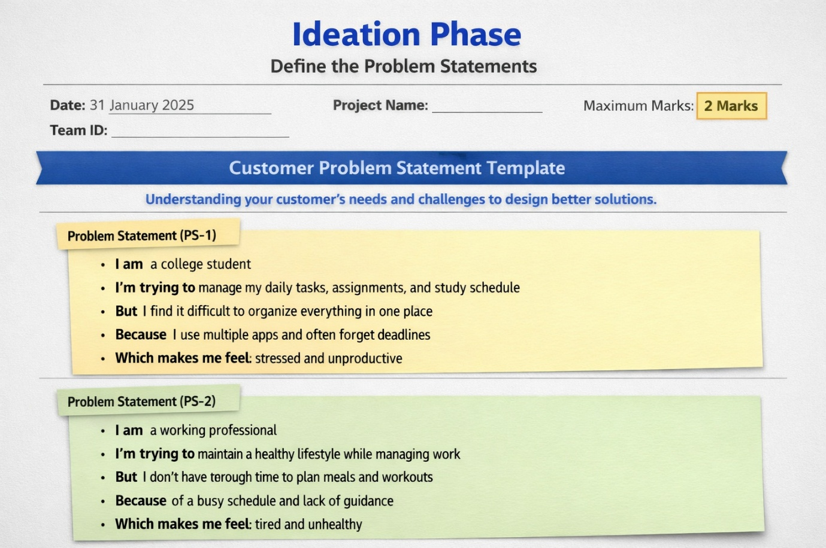

Reference: https://miro.com/templates/customer-problem-statement/

Example:



Problem Statement (PS-1)
I am a college student
I’m trying to manage my daily tasks, assignments, and study schedule
But I find it difficult to organize everything in one place
Because I use multiple apps and often forget deadlines
Which makes me feel stressed and unproductive

Problem Statement (PS-2)
I am a working professional
I’m trying to maintain a healthy lifestyle while managing work
But I don’t have enough time to plan meals and workouts
Because of a busy schedule and lack of guidance
Which makes me feel tired and unhealthy

